PROTECTING STREAMS IN AUCKLAND CITY DISTRICT PLAN September 2008

Submitters: Friends of Oakley Creek and STEPS

Objective: To have the district plan updated so that the key role of Auckland’s streams, wetlands and aquifers is enshrined in the District Plan, on a par with the volcanic and coastal environments of which they are an integral part.

Value of Streams, Wetlands, and Aquifers and springs:
- Existing and future recreation places for people and dogs – green spaces in the midst of an urban and constructed environment
- Creeks connect communities – Meola flows through the heart of the Mt Albert electorate
- Creeks feed our harbours – water quality and marine life in the harbour is directly dependent on how we treat and protect our streams
- Current and future fresh water source in the midst of our urban environment
- Current and future habitat for wildlife – native birds etc
Current and future habitat for rare plants – eg the last native fuschia in Auckland is by Meola Creek eg we have a rare nationally endangered moss in a creek near the zoo - Fissidens berteroi; eg Meola Creek and surrounding public reserves and recreational areas– provide a habitat at this time for: - eels, pukeko, ducks, grey warbler, tui, heron, spur wing plover.
- Wetlands have an economic value 30 times more than pasture according to the National Wetland Trust
- In Auckland – our aquifers and their quality, our streams and wetlands are an integral part of our volcanic heritage. Although they are underground and sometimes covered over – they need protecting on equal footing
- “Maori Society was …aquatic – it exploited and was in tune with the annual rhythms of rivers and seas… [which] were a food basket of waterfowl, fish and edible plants,…a means of getting about, and plants … provided materials for building shelter and rafts as well as fibre for clothing”. (P46 “Wetlands”)

Recommendations:
- We recommend tightening planning laws and their enforcement – to try to halt the degradation and look forward to future improvements. As we see it – this is the only hope for the very fragile state of our streams.
- Esplanade areas and esplanade strips 5B.5.3. These are a critical protection mechanism – which in practice are not extended to streams at this time. We want to see the public land surrounding streams formalized as esplanade areas. And for those lands in private hands – put in place esplanade strips and prevent development adjacent to (or on top of) stream beds. (see case studies – Haverstock Rd and Tate St for counter examples).
- Enforcement of esplanade strips and esplanade areas.
- Also promote the requirement in resource consents that Esplanade Reserves that are given to Council with subdivision should be planted in natives (there is a precedent here in a subdivision back in 2002). .
- Reconsider the wording of zone 3, or another lower density zone to include streams as well as volcanoes and cliffs.
- Apply zone 3 or other lower density zone to residential areas adjacent to creeks. Do not apply medium and high density zoning to areas adjacent to creeks.
- Do not allow building within 20 m of streams – either residential or commercial or other. See case study Haverstock Rd for a counter example.
- In order to reduce stormwater runoff, reduce the requirements for MAXIMUM BUILDING COVERAGE and MAXIMUM PAVED IMPERMEABLE SURFACE and increase the MINIMUM LANDSCAPED PERMEABLE SURFACE in all zones.
- In order to reduce stormwater runoff, enforce the controls on MAXIMUM BUILDING COVERAGE and MAXIMUM PAVED IMPERMEABLE SURFACE and MINIMUM LANDSCAPED PERMEABLE SURFACE. Limit the ability of developers to avoid or extend these requirements.
- Make it clear that sewage, drainage and waste water cannot go into creeks. We see there are at least 4 cases: new developments; new drains placed by existing landowners with permits; new drains placed by existing landowners without permits.
- Enforce the rules to prevent sewage, drainage and waste water going into creeks.
- Promote the use of “soft” engineering in relation to streams, and stop the ongoing hard engineering approaches to manage the problems of urban runoff..

Background and Rationale

Trends:
  - Wetlands are being nationally recognized – including Waiatarua in Auckland city.
  - In 1971 the immense value of wetland sites around the world was formally recognized in the Ramsar convention – which has 138 signatories including New Zealand.
  - However during the past 17 years since the AC DP was written, many of Auckland City’s creeks have been encroached on and water quality has further degraded, in part because of the non statutory nature of stream protection in the DP
  - At the same time many local groups have tried to take ownership of assisting AC to mitigate the effects of centuries of neglect and overlooking of the value of our few remaining natural water ways in Auckland City.

Auckland city streams – P116 of “ACDSRC Report”
All large streams have been extensively modified – most have piped or reinforced sections. Stream catchments now defined by stormwater network rather than original topographical catchment…. Surface stormwater during rainfall, often containing waste water from system relief overflows is the main contributor to stream flow. Consequently water flows in some streams are greater than would be predicted from topographical catchment area – especially where waste water overflows originate outside ht stormwater catchment – add significantly to stormwater flows.

Avondale, Oakley and Meola are the largest catchments (over 1000 Ha). Oakley is open for almost all its 12km length – making it the longest open fully urban stream in NZ…
Open freshwater sections of 6 largest streams are mostly bounded by reserves – generally for flood control rather than aesthetic and recreational benefits. In spite of this the reserves are valuable public amenities. Furthermore the availability of this public land adjacent to stream channels offers the potential to further rehabilitate the streams and so increase their public value.

P37 Stormwater runoff … increases significantly as the amount of impermeable surfaces increases with development. Urban development also reduces the availability of rain water soakage areas…. As urban development progresses the proportion of impermeable surface tends to increase and this generates increased volumes of runoff. In general terms every millimetre of rain falling on a square meter of impermeable surface gives rise to one litre of stormwater runoff…

District Plan
- The District Plan was written in 1991. Many things have changed and much new information has come to light since that time.
- The current District Plan is a legal document which sets out the Council's Policies and strategies for managing the natural and physical resources of the Auckland Isthmus for the future. However, the “significant natural features” are only Non-statutory guidelines for activities and development.
- We note that the Auckland City (AC) District Plan (DP) Annexure 2, p3 shows the following significant natural features which directly relate to this development:
- Volcanic Landform - Mt Albert – and other volcanic cones
- Aquifer – Underlying much of Eden Albert and surrounding district
- Ecological Area - Western Springs –a part of the Meola Catchment aquifer
- Ecological Area- Meola Reef (See Appendix 1)
- Significant Stream Channel – Meola Creek (one of only 5 publicly owned water courses in Auckland City)
In Part 5A Natural Resources, the DP lays out how important each of these elements is. These and a few other “particular environmental elements… can and must be maintained and where practicable enhanced” (p4). The DP also states the principal goal of the Resource Management Act, sustainable resource management will be achieved by adopting strategies to address natural environment issues.
4. We note that some zones are lower density and some relate to particular landforms – eg Residential 3 Zone Relatively low density development is provided for to reflect the unique environments created by the natural landforms.
Development of these locations at high densities would impact on the particular amenity values and aesthetic uniqueness of these areas.

Observations on Auckland City District plan:
- Our experiences with Resource Consent submissions are that the DP Annexures of significant natural features are overridden and ineffective. Everything is decided according to zoning, and the assumption is that no significant natural features are relevant, unless they are specifically mentioned in the body of the DP (as are volcanic cones). See case study 1 in Appendix 2.
- Part 5B Coastal. Detailed protections of coastal environments appear to have no linkage to the streams on the isthmus which feed them.
- Streams as significant natural features have not been valued or protected historically. They are often treated as drainage ditches. P 194 of “ACDSRC Report”: “The detailed habitat survey showed that 16 sites had low or moderate low habitat quality. These sites usually had concrete channels and were surrounded by riparian vegetation dominated by short grass. These sites represent the extreme engineering solution to managing urban runoff and have resulted in streams that serve only as drains“. “Management of urban streams solely as drainage conduits has consequently greatly altered their habitat quality and has helped contribute to their poor ecological health.”
- P37 of “ACDSRC Report”: Auckland City and Metrowater are responsible for maintaining the public stormwater drainage system that serves properties roads and reserves as well as five public watercourses: Oakley Creek, Meola Creek, Motions Creek, Newmarket Stream and Remuera Stream
- However in fact, the responsibilities for every creek are so distributed. While they have many stakeholders, they have no real owners.

Responsibilities for one creek as an example of Distributed Responsibilities:

Resource | Responsibility | Comment
Meola Creek | Auckland City Council – owner | (Managed by Metrowater)
Water and waste water (including sewage) | Metrowater – ‘Retail’ sewers
Water and waste water (including sewage) | Watercare Services- ‘Wholesale’ sewers
Storm water | Auckland City Council- owner
Combined sewers (storm water and waste water) | Auckland City Council- owner | Contracts Metrowater to separate them (but Meola is not funded)
Creek bed | DOC - owns the water course in Meola Creek? | DoC letter says that it is manage d by Auckland City Council
Water Quality in Meola Creek | Auckland City | Overall responsibility
Water Quality in Meola Creek | Auckland Regional Council | Issues Resource Consents for Water

- Water quality is the responsibility of Auckland city – yet there are no processes in place to monitor, or clean it up.
- We believe that the DP is not yet strong enough to prevent more unnecessary reduction of the value of these natural features – see case study 1 Appendix 2.
- Further – we see that even putting planning controls in place is not sufficient if there is limited enforcement.
- The AC DP and the various plans of the ARC are not in synch with each other. One example of ARC requirements of AC DP is attached in Appendix 1.

Proposed Solutions for overflows: Solutions include Watercare Services upgrade of the interceptor. But given that this has not occurred in the past 17 years, and is unlikely to occur in the next 20 years, Auckland City cannot wait for this.

REFERENCES

- Auckland City Drainage System Resource Consents, Assessments of Environmental Effects, March 2001 [“ACDSRC Report” available on line from Metrowater]
- Meola Integrated Catchment Management Plan Phase 2 Report – Remedial Options (Sinclair Knight Mertz 2002) [“ICS report”]
In addition STEPS can provide a copy of a recommended unpublished report:
- Assessing and mitigating the environmental impacts of stormwater flowing into Meola Creek and its receiving environments. From the School of Geography and Environmental Science, University of Auckland, October 2005. [“UA report”].
Further information was presented in a legal case:
- Statement of Evidence by Michael McQuillan before the Environment court (St Lukes Park Owners Committee vs Auckland City Council) 11 October 2004 (RMA 626/02) [“McQuillan evidence for ACC”]
- Wetlands of New Zealand (Janet Hunt 2007) [“Wetlands”]
APPENDIX 1
OTHER PLANNING FRAMEWORKS RELATING TO STREAMS

Te Tokaroa Meola Reef :
  - is the northern end of 10km lava flow
  - is 20,000 years old
  - flowed down a valley from Three Kings
  - extends 2 km over Waitemata to within 500m of north shore
  - is partly completed bridge built by fairies – reported Maori legend
  - Meola Creek discharges to the west and Motions Creek to the east

Te Tokaroa Meola Reef is designated as:
  - a Coastal Protection Area 2 under the Auckland Regional Coastal Plan;
  - its marine vegetation zoned as Protection Area 1; and
  - a conservation zone under the 1987 Waitemata Harbour Maritime planning scheme (p 138 ACDSRC Report)

ARC POLICY
As noted in the MINUTES OF A MEETING OF THE EDEN ALBERT COMMUNITY BOARD HELD ON WEDNESDAY, 27 AUGUST 2008
“The Auckland Regional Council (ARC) has jurisdiction over water bodies in the region. The ARC Regional Policy Statement (RPS), chapter 8, which deals with Water Quality, outlines a range of issues associated with degraded water quality within the region, and identifies a number of methods and actions to undertake with the goal of improving water quality. Meola Creek is classified within chapter 8 as a body of water with significantly degraded water quality (Table 8.2).
The following lists the relevant parts of the plan relating to bodies of water such as Meola Creek;
8.4 Policies: Development and Redevelopment
1. Land use intensification in urban areas shall only occur where adequate provision is made for:
(i) control of sediment discharges;
(ii) control of stormwater discharges;
(iii) collection, transport, treatment, purification and disposal of sewage;
(iv) protection of the quality of groundwater recharge especially into aquifers used for water supply purposes;
(v) protection of water quality and riparian margins;

8.4.5 Methods 4. District plans shall not provide for land use intensification in sewered catchments that are at a maximum capacity for sewage disposal and/or have inadequate drainage (which is resulting in hydraulic overloading of the sewers) unless services are upgraded to an adequate capacity, or a commitment made to upgrading, sufficient to handle the demand that will result from the intensification.

APPENDIX 2 AUCKLAND CITY CASE STUDIES

CASE STUDY 1 COMMUNITY CARES FOR OAKLEY CREEK
Oakley Creek – has Auckland’s only waterfall – and has received awards.
http://www.oakleycreek.org.nz/

There are numerous other examples.
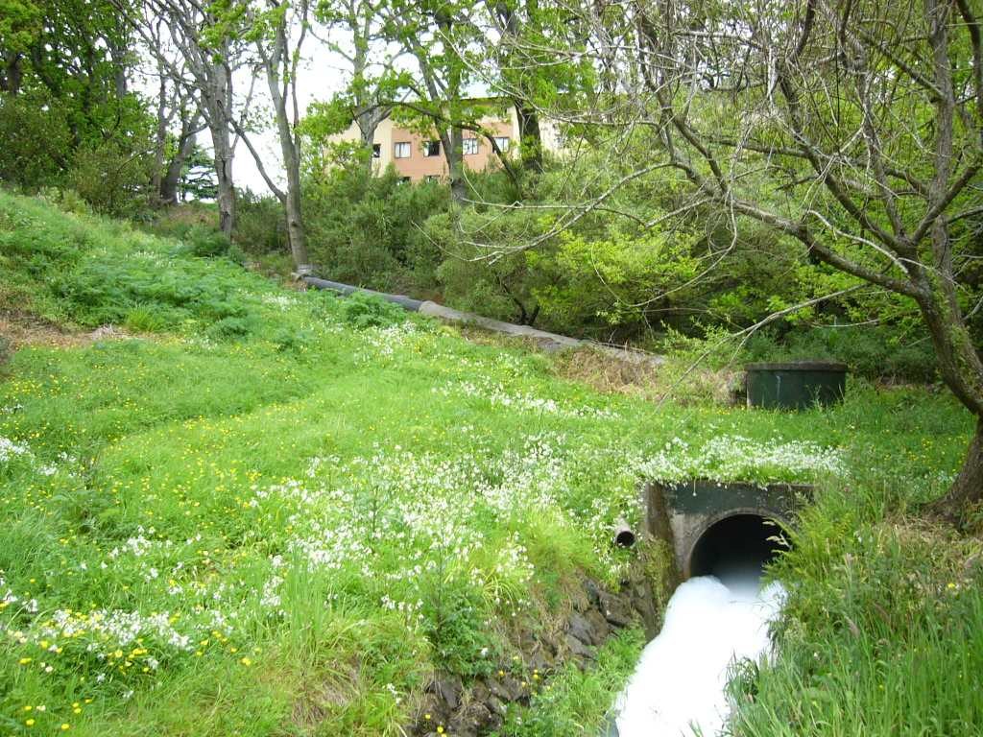

http://www.stuff.co.nz/auckland/local-news/central-leader/747468

Water care teams witness Oakley Creek spill
Central Leader
Last updated 12:54 04/12/2008
A discharge of harmful chemicals into Oakley Creek has killed hundreds of native fish and left local environmental groups fuming.
Workers from Wai Care, Metrowater and Gladstone Primary School were routinely cleaning up the creek on Monday when they noticed foamy chemicals pouring into the stream from a stormwater drain.
The chemicals spread quickly, killing fish and eels.
The drain where the chemicals spilt from is located at the back of the Unitec site in Mt Albert, but also serves houses and buildings in the area.
Unitec chief executive Rick Ede says while it is working closely with the Auckland Regional Council to determine the exact cause of the pollution, initial inquiries suggest the contamination may have been caused by some roof treatment carried out by contractors on one of its buildings.
"Whether or not this was the actual cause of the pollution will not be known until the Auckland Regional Council has completed its comprehensive investigation into the matter," he says.
Friends of Oakley Creek spokeswoman Wendy John says the pollution is a disaster for animal life in the stream.
"It was avoidable, totally unacceptable, and should never have happened," she says.
"It is an example of how fragile our natural environment is, and how just one act of negligence can cause so much harm," Ms John says.
The pollution was discovered on Monday about 10.30am while the group was carrying out a number of activities, including water testing.
They called the Auckland Regional Council for help and senior pollution response manager Matt Harrex investigated.
He says about 100 metres of the stream was affected and because there had been heavy rain that morning, the chemicals spread quickly.
Ms John was also at the creek when the pollution was discovered and says the water turned into a "death trap" for the fish and eels within seconds.
Mr Harrex says the council is taking the incident seriously and will be carrying out tests to determine what type of chemicals were spilt. That could take up to 20 days.
Factors including whether the incident was an accident, negligent or deliberate will be taken into account and those responsible could face prosecution.
Mr Harrex says the incident highlights the need for people to remember that rainwater and nothing else should go down stormwater drains.
If any pollution is seen in local streams, people should report it to the Auckland Regional Council’s pollution hotline on 377-3107.

CASE STUDY 2 Meola Creek - 94-130 Haverstock Rd

Situation
- This address borders Meola Creek headwaters. It is owned by a government organization. It is zoned Residential 6A “medium intensity”.
- Also at 96 Haverstock Rd is the largest single outfall from Watercare Services ‘wholesale’ sewer interceptors. Overflows amounted in 1992 year to almost one Olympic swimming pool per day (average) of raw sewage and stormwater containing zinc, copper and other contaminants.
- Little or no sewer separation has occurred in this catchment since 1992
- No routine monitoring of water quality is carried out
- During the 1990s, local authorities piped this part of the stream in order to disguise the overflows. The overflows come above ground at 160-162 Haverstock Rd – where the same government organization has built a state house within 5 meters of the creek, within the past 5 years.
- The overflows then flow through Kerr Taylor Reserve and the grounds of Mt Albert Grammar School. Frequent reports containing data are available on the public health risks this poses. Most are written by Auckland City or Metrowater – and a few are in the references above.
- Plant and Food (Hort Research) staff have recently restored a wetland above the creek, and local groups were working to daylight the creek and restore the natural flow from the aquifers along the creek bed. STEPS and Metrowater have carried out two plantings downstream from Haverstock.

The Plan
- The owner wished to improve economic return on this site – and planned to move 19 existing houses and replace them by 41 units.
- They met with three other government organisations – DOC (who owned the creek bed); ESR and Plant and Food – who owned land the other side of the creek bed; and decided to straighten the inconvenient meander in the creek, and change their boundaries. Net result would be that the headwaters would be behind a high security fence inside a secure Hort Research site; and the owners could build a concrete access lane on top of the former creek bed.
- DOC already delegated their responsibilities to Auckland City – and raised no objection
- Hort Research and ESR signed it off – then put in submissions opposing the resource consent. They did not inform their Environmental Network of Scientists that this was under way.
- They applied to Auckland City for Resource consent in January 2008. STEPS and over 40 other submitters opposed it on various grounds
- In June- July 08 they applied to ARC for permission to move the creek. They did not consult with tangata whenua, nor with STEPS who clearly had raised concerns.

DP applicability
- In September – Auckland City Resource consent hearings were held – but ARC had already granted a resource consent declared that the Meola creek was not a creek any more because local authorities had piped it !
- The arguments of the owner are focused on the statutory requirements – not on the significant natural features in the Annexure.
- Currently – this has gone to appeal in the Environment Court
Case study 3
MEOLA CREEK - Mt Albert Grammar School (MAGS) and Kerr Taylor Reserve

With Metrowater’s assistance, the local community have been able to participate in planting to convert
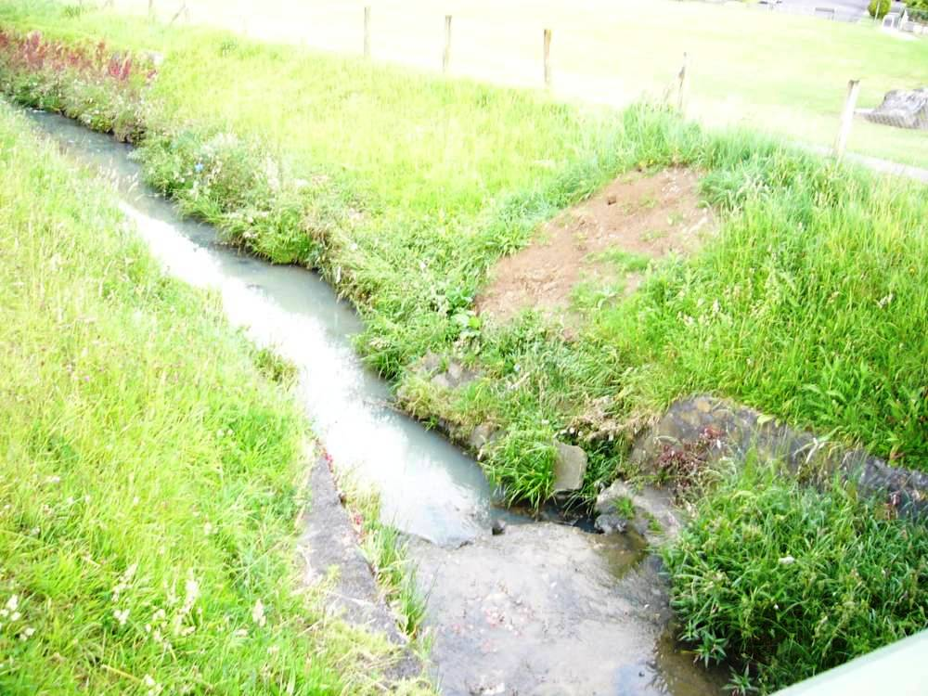
to
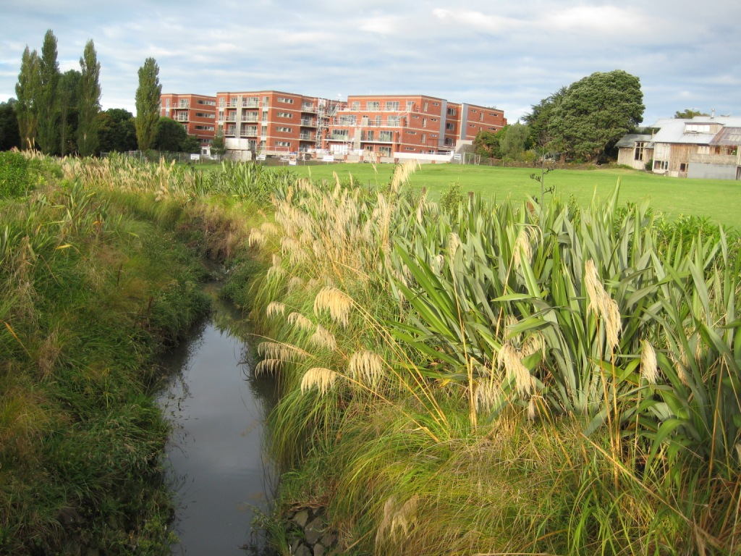

MEOLA CREEK - PROGRESS:

Several practical steps have been taken to start to protect the upper creek

June 2007 – Metrowater planting north of bridge linking MAGS and Kerr Taylor Reserve
May 2008 – Metrowater commission Te Ngahere revegetation plan for Roy Clements Treeway on MAGS land
May 2008 City Development Committee commits to improve Meola Creek
June 2008 – Hort Research plant wetland at the headwaters of the Meola Creek (at “DSIR”, Mt Albert Rd)
June 2008 - STEPS Application to EIF for planting another wetland
August 2008 – Eden Albert Community Board notice of motion to approach ARC in relation to management of Meola Creek as a contaminated water way.
August 2008 – Metrowater boardwalk and planting on MAGS land to south west of St Lukes Garden Apartments – more planting planned
March 2009 – Published portfolio of projects to clean up Meola Creek.

