

Annual General Meeting 2014

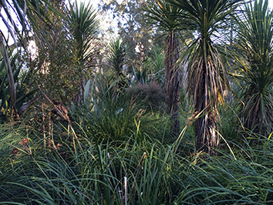

**ALL WELCOME**

After the AGM, there will be brief updates on several topical issues including: progress of the wetland planting; daylighting of Upper Meola Creek; and Watercare on the Central Interceptor and its impact on the Roy Clements Treeway. Following the updates, there will be a general panel/floor discussion with Stormwater, Local Board Member Graeme Easte, Morphum Environmental, and STEPS Deputy Chair Nick Goldwater for these issues and those raised by the audience. *Come along and have your say :)*

**WHistoric Alberton House, 100 Mt Albert Rd**

**7pm, Thursday, 3 July 2014**