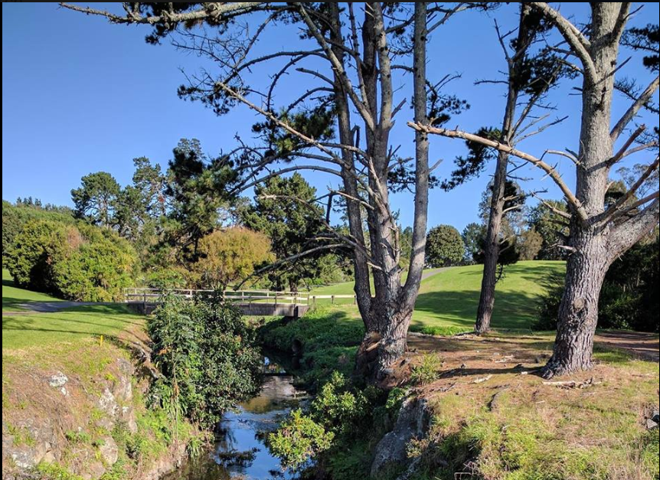
Join members of the St Lukes Environmental Protection Society (STEPS) for the third and final stage of the Meola Waititiko Mountain to Sea Walk, from Western Springs to Meola Reef on the Waitemata!
This follows on from the first and second walks from the summit of Owairaka Mt Albert to Kerr Taylor Reserve, and from Kerr Taylor to Rawalpindi. It’s a chance to learn about the Meola Creek Waititiko and its catchment and aquifer, while stretching your legs in good company.
Details of the walk can be found here: Meola Mountain to Sea Walk - 3rd leg
When: Saturday 13th October 2018 at 10.00 am
Where: Eastern side of the Western Springs Garden Community Hall Great North Road. (Parking in the car park.)
What to bring: Sunhat, sunblock, raincoat, water bottle – along with family members.
There will be cars at Meola Road carpark to shuttle walkers back to the starting point.
If weather looks poor, see https://www.meolacreek.org.nz on the day at 8am to check for cancellation. For further information contact us via our website.

We hope to see you there!

